Home Learning Week 6
YR Tower Hill – Sears and Pisa Class
 | Monday | Tuesday | Wednesday | Thursday | Friday
Reading | Listen to the story of the day read by a teacher at school  https://www.towerhill.hants.sch.uk/website/story_of_the_day/467176 | Play Rocket Rescue on Phonics Play  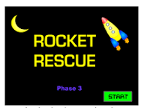 | Can you make some flashcards of tricky words  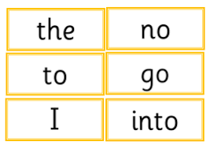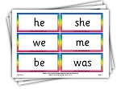 | Listen to The Egg Drop by Mini Grey being read on Youtube.  Can you draw a picture of something that happens in the book and write a sentence to say what your picture is of. | Make some Easter cards and write them for your family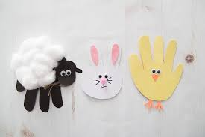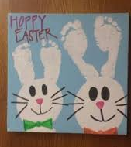
Writing | Draw what you had for dinner last night on a plate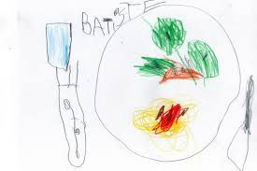 | Draw or write a postcard to a friend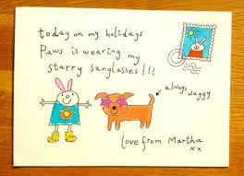 | Make a list of as many nursery rhymes as you can think of. | Write a sentence to describe what is happening in the picture  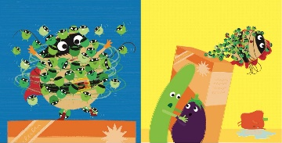
Maths | Can you bake some cookies and weigh the ingredients? 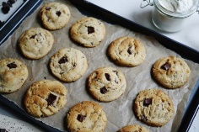https://www.netmums.com/recipes/chewy-chocolate-chip-cookies | Draw around your families feet and cut them out. Put them in order from smallest to biggest. 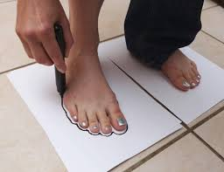 | Make a number between 0-10 and draw as many facts as you can about that number  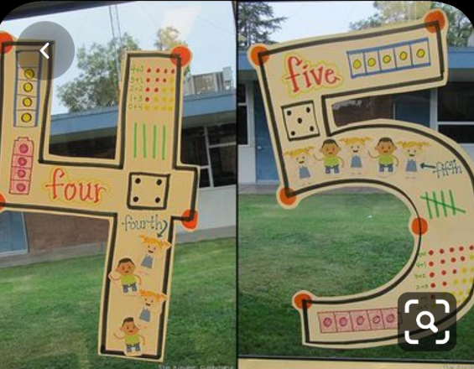 | Play dice addition 4 in a row’  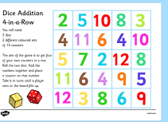 | Can you match the post it notes to the houses  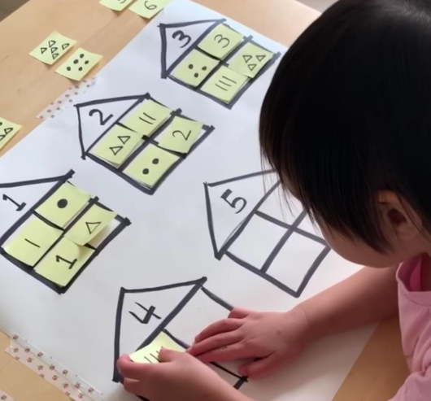
Other | Can you hit the target? Use a washing basket and some cuddly toys. 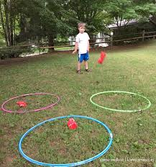 | Can you make some finger puppets for a well-known story?  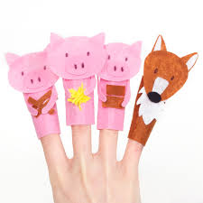 | Play Easter bingo 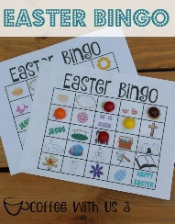 | Create a chick like the picture if you don’t have paint you could draw round your hands and feet and colour them in. | Go on an Easter egg hunt around your house – hide some toy eggs or plastic food and get someone else to find them or you could write clues

