Year 1 Home Learning Menu – Week 14
Have a go at as many of the activities as you can. There are 3 Maths and 3 English lessons for you to complete which you will find more details of in the Maths and English Support Packs. You will need to work through the lessons in order. Have a look at the suggested timetable to help you. There are also 3 topic based activities for you to complete which link to the learning you would have completed at school this term.
Maths task 1  Subtraction  Remind yourself how to subtract by completing the bottle worksheet, then watch this video.  https://www.youtube.com/watch?v=-BLNxW2Ya5M  Once you’ve watched this video complete the number line task. | Maths task 2  Subtracting Elmer  Use the number line at the bottom of the page to complete the subtractions to get Elmer his colour back! | Maths task 3  Mixing addition and subtraction  Making sure you take extra care looking at the symbols, can you help Joe complete his homework?
English task 1  Rainbow Fish  Listen to the story of the Rainbow Fish being read on the below link  https://www.youtube.com/watch?v=BzZuS3ze-Ho  In your literacy support document, complete the Rainbow Fish book review. Think about what you liked about the story, and how you think it could be even better. Can you work out the hidden message behind the story? | English task 2  Rainbow Fish  In your literacy support document, can you fix the Rainbow Fish sentences? Words are spelt incorrectly, and they are missing capital letters and full stops. Use the story to help you. | English task 3  Rainbow Fish  The Rainbow Fish gave away his most prized possession, his scales. What is your most prized possession? In your literacy support document, can you draw a picture of it and tell me why it is so special?
Topic task 1  Art  Create your own picture of a rainbow fish. You may want to use a range of different materials.  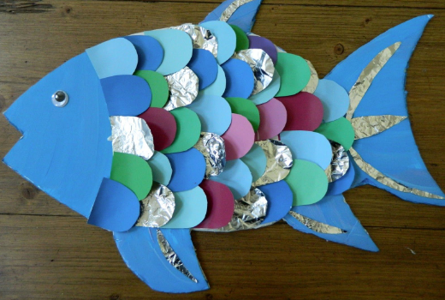 | Topic task 2  PSHE  The Rainbow Fish learnt to be a good friend, talk to an adult at home about the different ways to be a good friend. | Topic task 3  DT  Can you use some of your own toys to make a toy mobile?  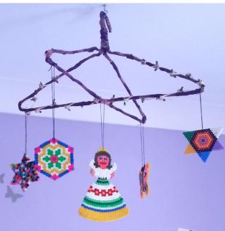
Extension tasks:
- Maths – Play a subtraction game https://www.topmarks.co.uk/maths-games/subtraction-grids
- English – Using books or the internet, can you find out 2 facts about a creature that lives in the sea?
- Topic – Can you create a poster about being a good friend?

