The Little Red Hen
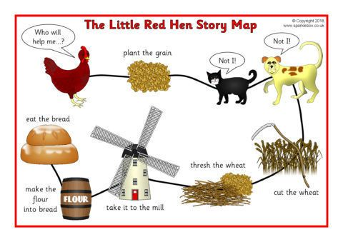
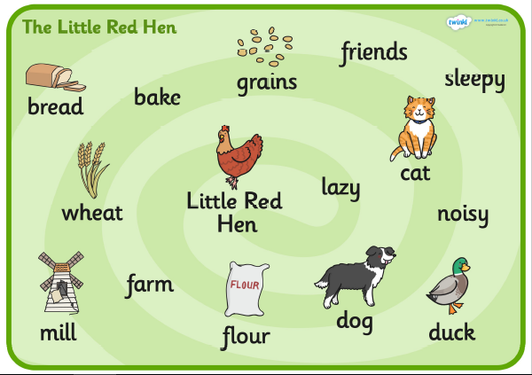

The Little Red Hen …

The animals …..
Farmyard Phonics
Can you use your phonics to sound out the farm animals. Remember that some of the are special friends.

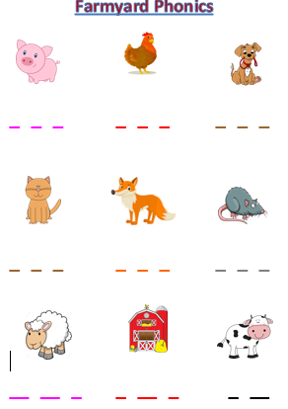

Making Animal Music Patterns
Print the animals and put them into a pattern. Come up with your own action/sound to go with each picture.

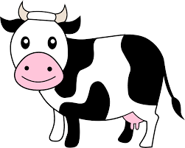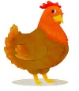
Clap Clap Stamp Clap Clap Stamp
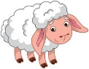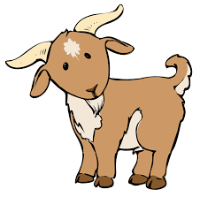

Click Bang Click Bang Click Bang Click Bang

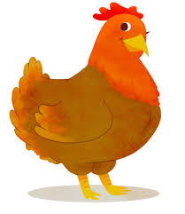
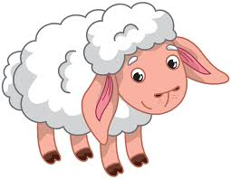
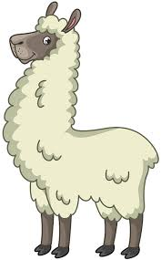

Toilet Roll Farm Animals
Using any recycling you have or craft resources can you make your own farm animal. You might want to draw around your hand for feathers, draw and stick on some googly eyes or use cotton wool to make a fluffy sheep. Then upload a picture to Eylog.
