Year 4 Home Learning 18.5.20-22.5.20
Topic Support Document
You will be focusing on Design and Technology and History. You will have 2 tasks focusing on an Anglo Saxon village and 1 Design and Technology task of construction, following on last week’s plan. If you have any questions please feel free to message or email or class teacher.
Topic 1: Design and Technology.
Using your plan from last week and the recycled materials you have collected, construct your boat. It would be great to see if it floats! You can test this in the bath or paddling pool. Upload an image of your boat and a small paragraph describing how you constructed it to the appropriate VLE portal.
Topic 2: Anglo-Saxon Village Advert
Complete an advert to describe and sell an Anglo-Saxon village. You will need to consider the layout of homes, materials and the different jobs available within the village. You may choose the format in which you complete your advert. Use the information below to help you.
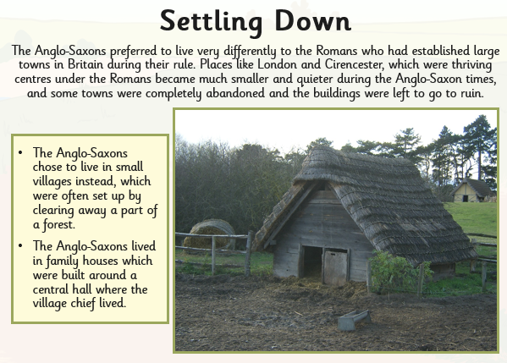

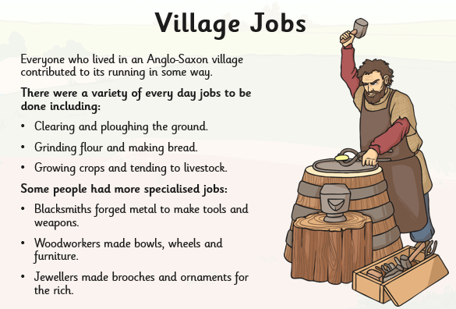

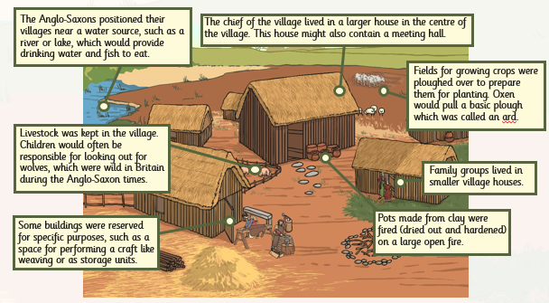

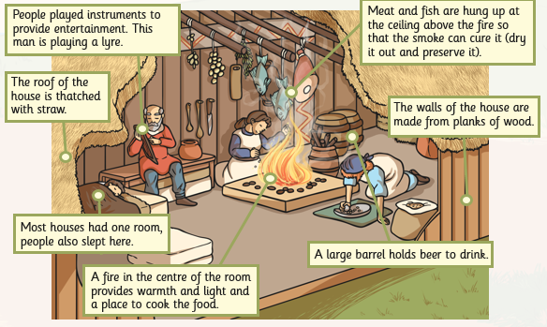

Topic 3 – History (Comparing Anglo-Saxon’s to Modern Day)
Using your knowledge of an Anglo-Saxon village and the roles within it, complete a Venn diagram comparing it to your home/town. You will have to consider both similarities and differences between the two.
Use the Venn diagram on the next page to complete the activity. Remember the middle is where you put aspects that are the same between the two .e.g. living with members of your family.
Things to think about:
- How are the houses/flats/homes organised?
- What is the structure within your house?
- What is your home made of – materials?
- Who do you live with?
- What jobs are in your town?
- How do you get and cook your food?

Anglo-Saxon Village
Modern Day Home/Town

