Year 2 Topic Support Pack – Week 7
History – Grace O’Malley
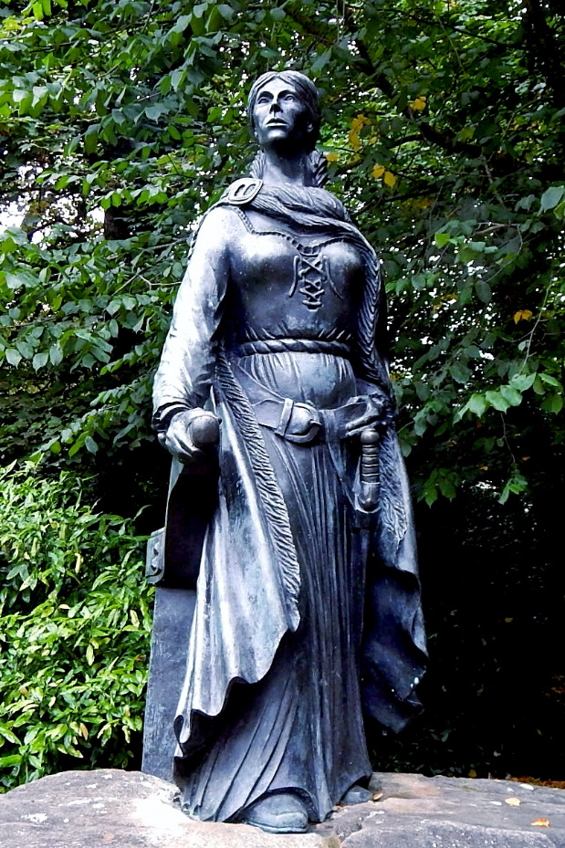
The picture below shows the lady who is the focus of our pirate topic. Her name is Grace O’Malley. The Irish spelling of her name is Granuaile which means ‘Grace without hair or bald’. We will look at why this is at a later time. After your research on pirates last week, looking at lots of pictures and thinking about what they look like, does Grace look like a pirate to you? Why or Why not? Write down your reasons under this picture of her statue. Then can you think about what you would like to find out about Grace and write down your questions.

__________________________________________________________________________________________________________________________________________________________________________________________________________________________________________________________________________________________________________________________________________________________________________________________________________________________________________________________________________________________________________________________________________________________________________________________________________________________________________________________________________
Geography – Map Symbols
First watch the video to understand what a map is and why we use them. Then look at the information below to think about what maps show us and understand the importance of a key and the symbols used.
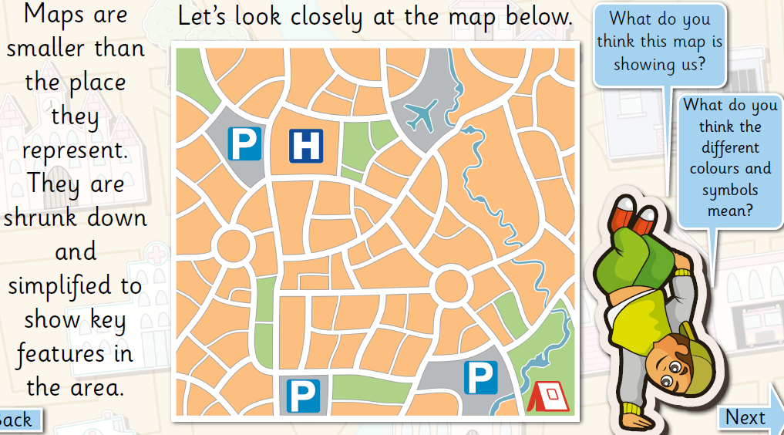

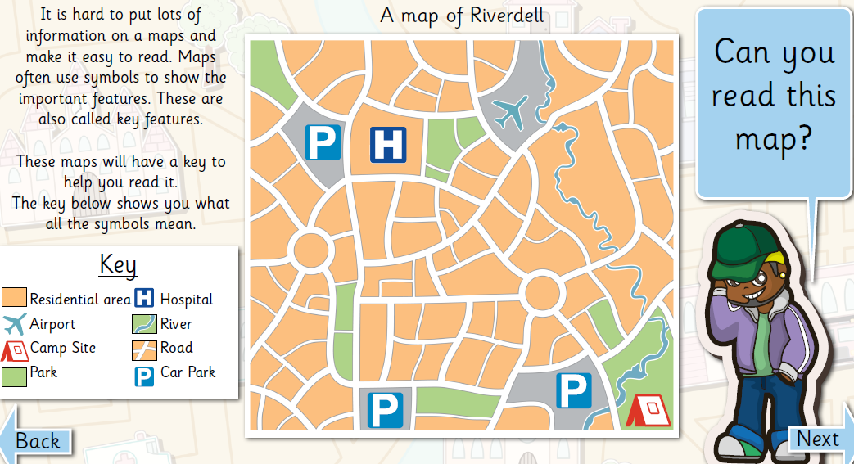

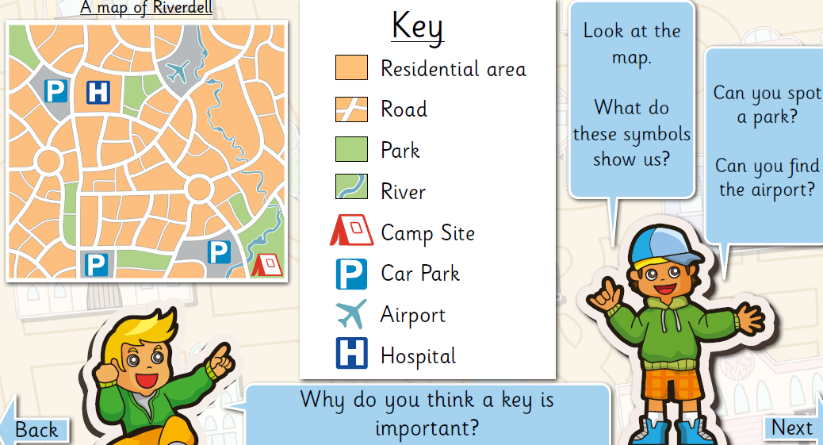

On your daily walk can you draw or take photos of the key features you see. Think about what places are important to you and what landmarks stand out to you. What places do you think would help someone find their way around your local area? Challenge! Could you add a key to your map? What symbols would you use?

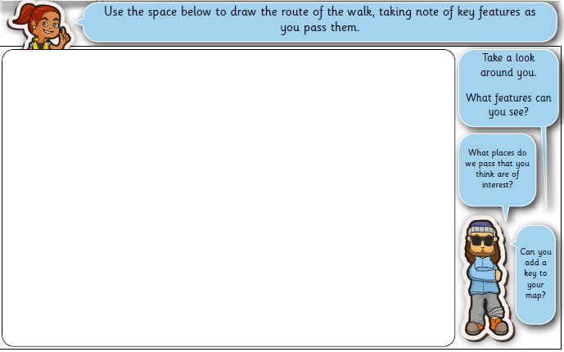

Science – The life cycle of a plant
First, watch the BBC Bitesize video to help explain the life cycle of a plant. Then, using the information below, can you draw each of the stages in the life cycle of a plant? Underneath your life cycle, name each stage.
