Week 10: Literacy Lesson 1
Listen to the story of ‘The Snail and the Whale’ by Julia Donaldson being read from the link on the home learning menu. Use your inference skills to answer the following questions.
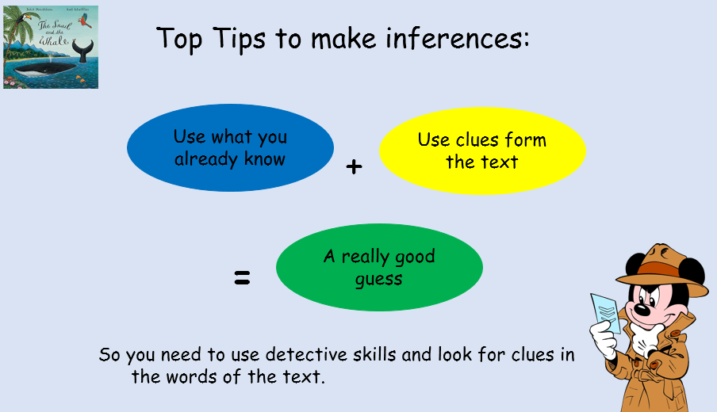
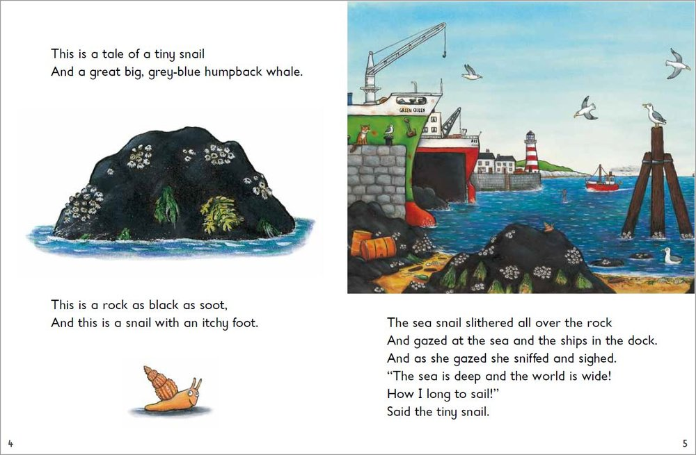
How does the snail feel at the end of this page?
__________________________________________________________
Why do you think the snail felt like this?
____________________________________________________________________________________________________________________________________
How does the snail feel at the end of this page?
__________________________________________________________
Why do you think the snail felt like this?
_________________________________________________________________________________________________________________________________________________

“These are the speedboats, running a race.
Zigging and zooming all over the place,
Upsetting the whale with their ear-splitting roar,
Making him swim too close to the shore. “

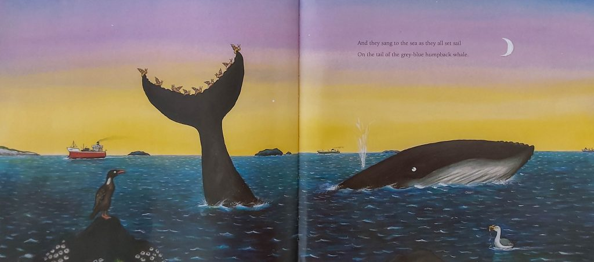
“And they sang to the sea as they all set sail
On the tail of the grey-blue humpback whale.”
How does the whale feel at the end of this page?
__________________________________________________________
Why do you think the whale felt like this?
_________________________________________________________________________________________________________________________________________________
How does the snail feel at the end of this page?
__________________________________________________________
Why do you think the snail felt like this?
_________________________________________________________________________________________________________________________________________________

Literacy Lesson 2
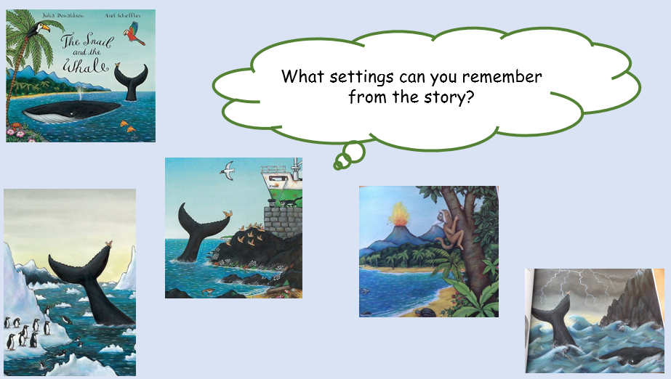

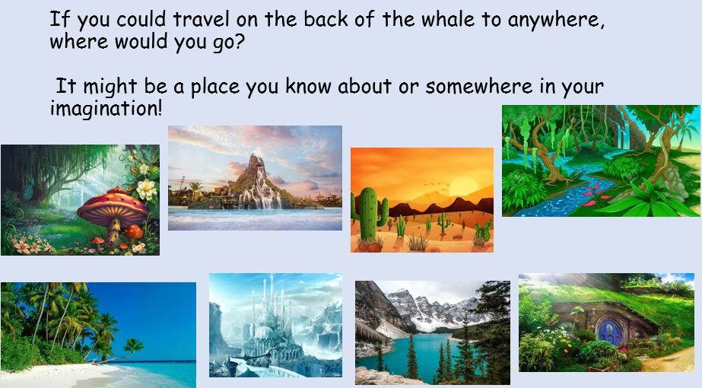

Create a picture of your setting-adding as much detail to your drawing as possible.

Challenge: Can you write a list of all the different things you can hear in your setting?
________________________________________________________________________________________________________________________________________________________________________________________________________________________________________________________________________________________________________________________________________________________________________________
Literacy Lesson 3
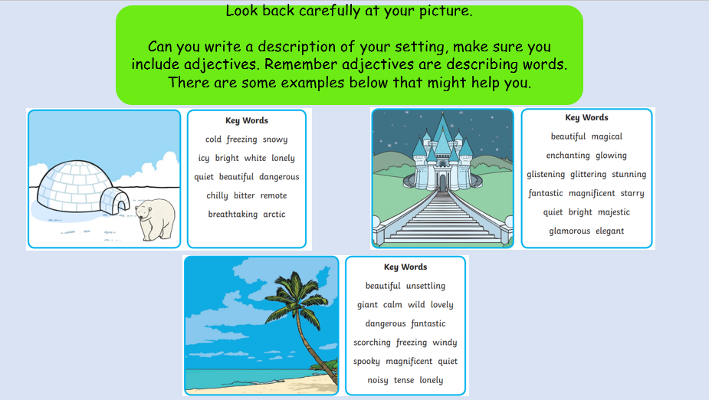

Here is an example for you:
The warm wind felt soft. I looked up at the white fluffy clouds which hid the sun. The calm turquoise sea was freezing but looked magnificent.
I could hear birds chirping in the lush green trees. It was such a beautiful day!
Remember to try to include:
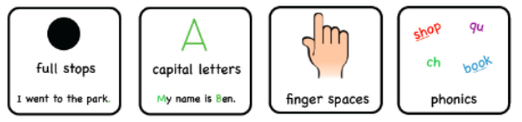
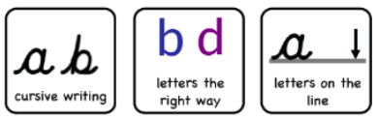

Describing My Setting
______________________________________________________________________________________________________________________________________________________________________________________________________________________________________________________________________________________________________________________________________________________________________________________________________________________________________________________________________________________________________________________________________________________________________________________________

Extension Task: What would be your favourite thing to do when you reach your setting?
________________________________________________________________________________________________________________________________________________________________________________________________________________________________________________________________________________________________________________________________________

