Year 1 Maths Support Pack - Week 6
In this pack, you will find instructions on how to complete your Maths lessons for this week. We are learning about doubling and grouping this week and you will need to watch some short videos to help you. Follow the links on your home learning menu, or on our class page on the website, to watch the videos. You can then complete the worksheets by printing them, or viewing them on the screen and writing the answers on your own paper.
Lesson 1 - Making Doubles
Watch the short video that links with lesson 1 – Make Doubles (Summer Term - Week 1 (w/c 20 April) Then complete the tasks below. When completing the tasks please feel free to use objects to help your child, if they need it. If your child finds this straight forward then get them to use objects to prove their answers and mark their own work.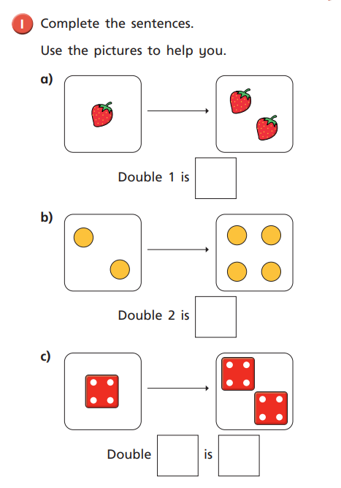
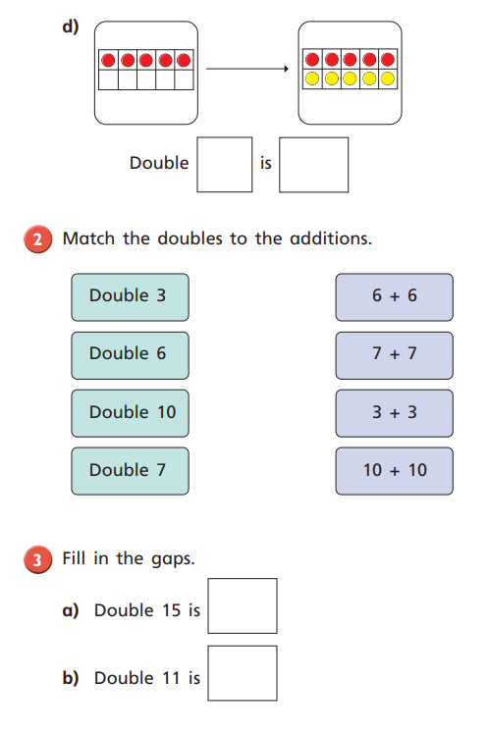
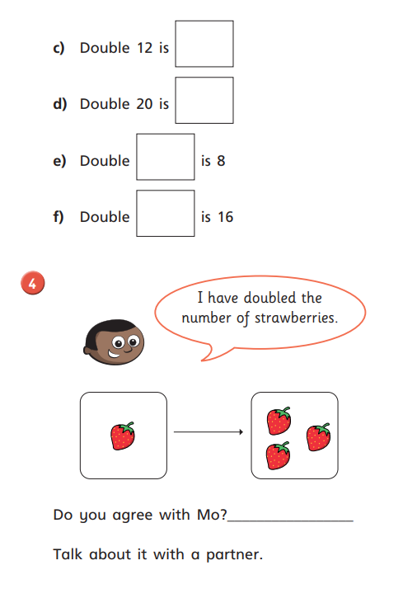

Challenge:
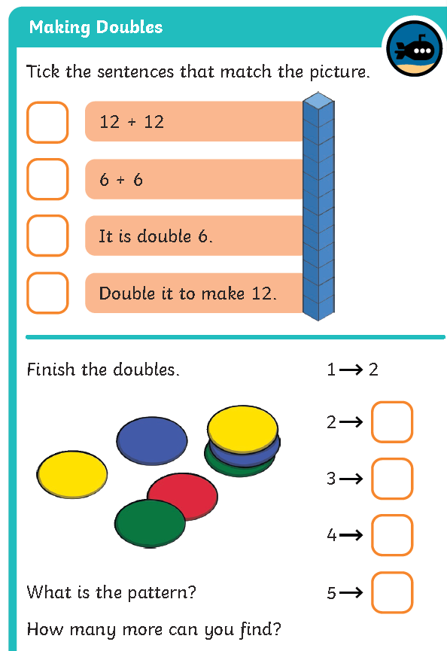

Lesson 2 – Make Equal groups
Watch the short video that links with Lesson 2 – Make Equal groups (grouping) then complete the tasks below. When completing the tasks please feel free to use objects to help your child, if they need it.

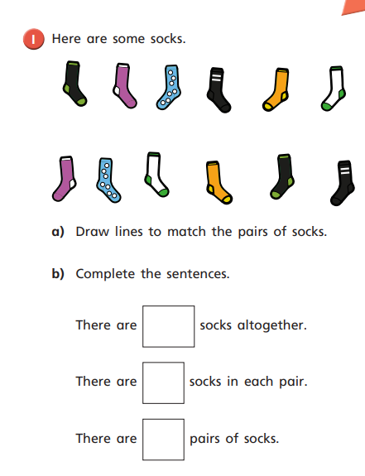
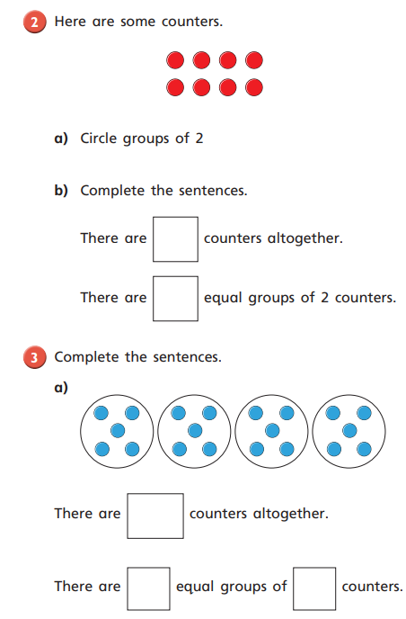
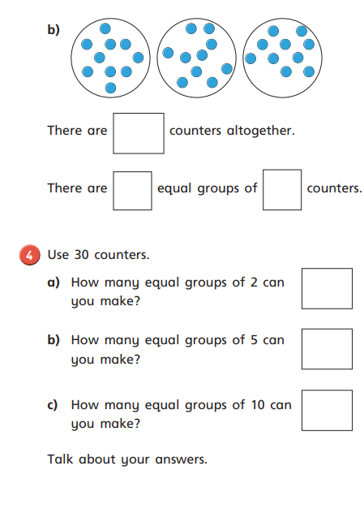
Challenge: 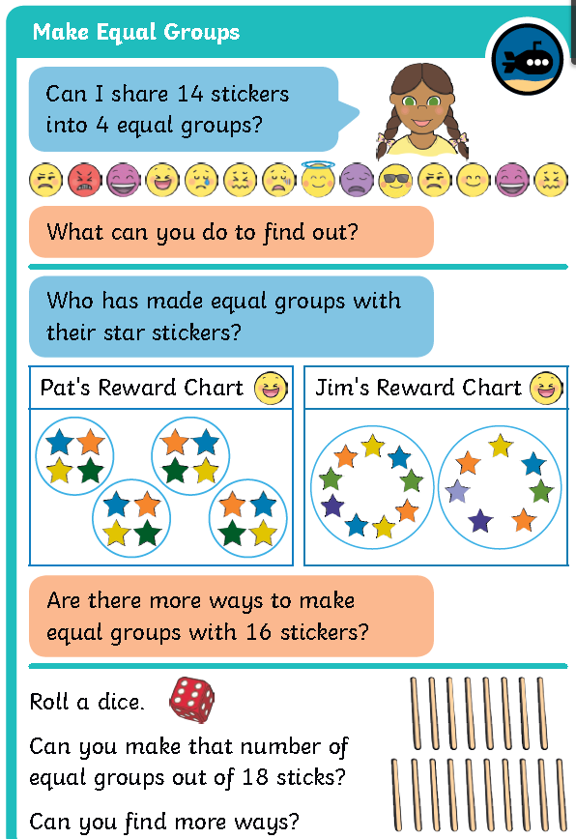

Lesson 3 – Make Equal Groups (sharing)
Watch the short video that links with Lesson 3 – Make Equal groups (sharing) then complete the tasks below. When completing the tasks please feel free to use objects to help your child, if they need it. 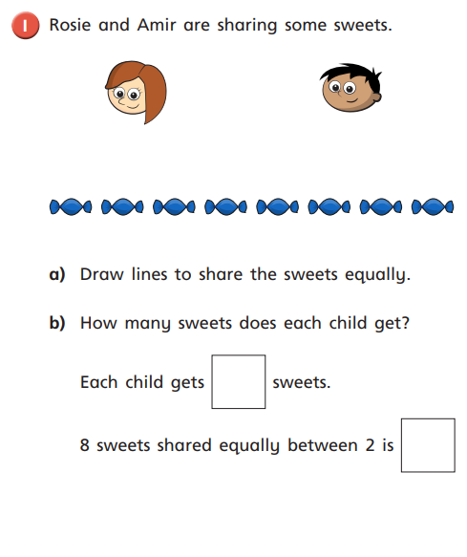
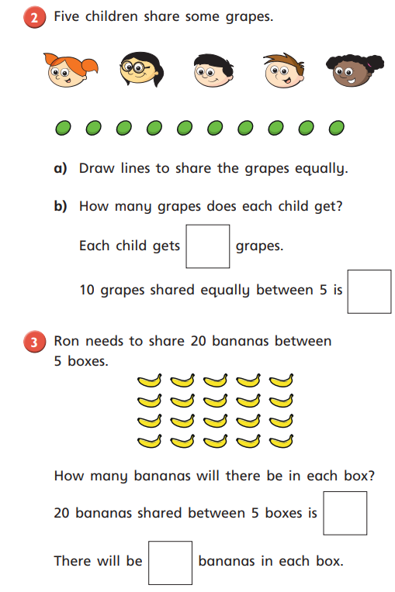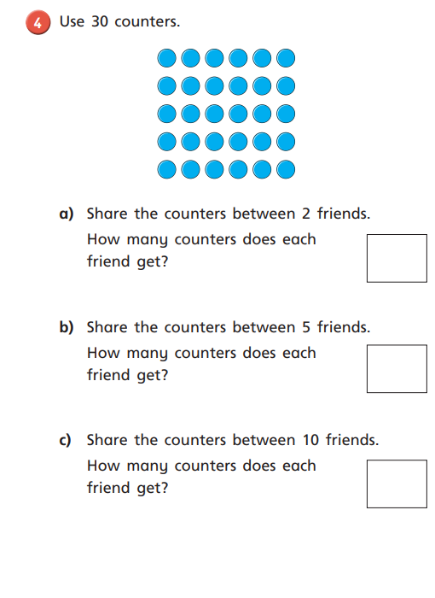
Challenge (adding): 