Year 1 Maths Answer Pack – Week 9
Week 9 Lesson 1: Representing numbers within 50
1. There are 26 eggs in total. 26 is 2 tens and 6 ones.
2a. 2 tens and 3 ones is 23
2b. 3 tens and 7 ones is 37
2c. 3 tens and 4 ones is 34
3. You should have three groups of ten and four ones using small objects, write 3 tens and 4 ones and the 2-digit number 34.
Lesson 2: Counting with tens and ones
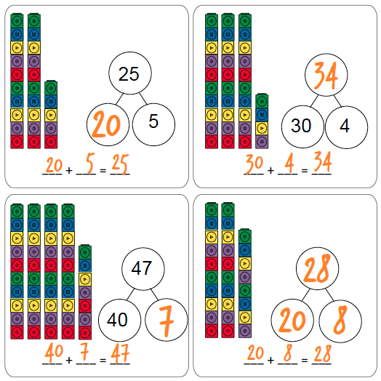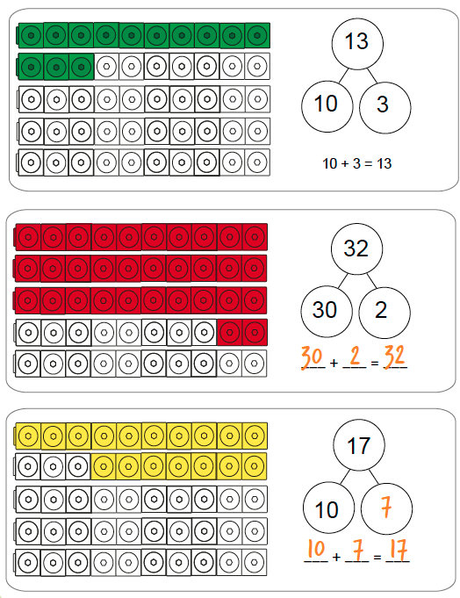
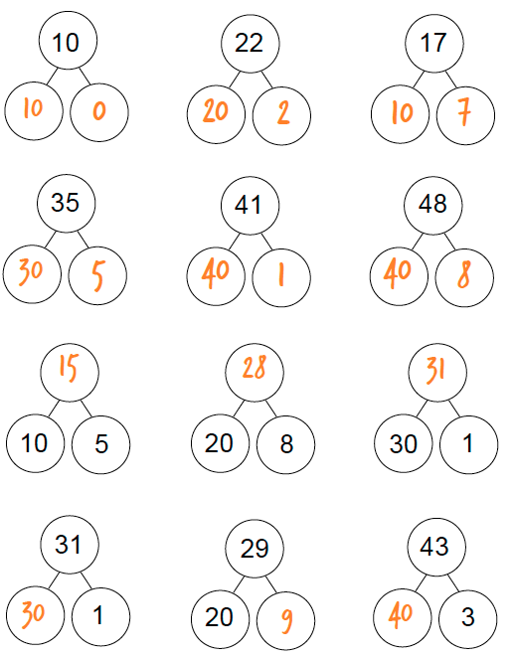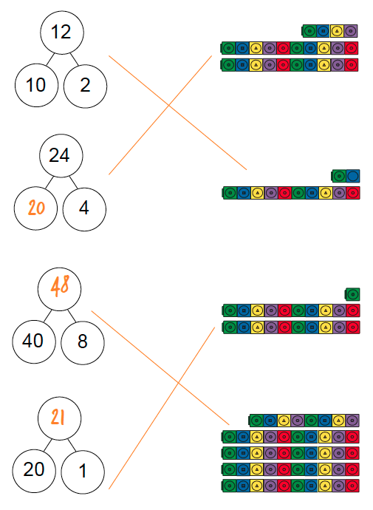
Lesson 3: Comparing numbers of objects
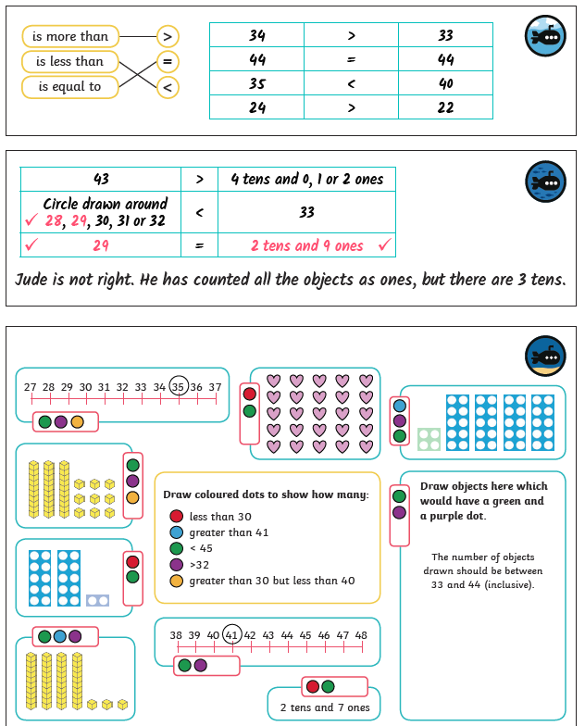
Challenges