What a Wonderful World!
Year 2 Homework - Autumn 1
Choose at least one of the tasks to complete at home this half term. You can choose when to bring your homework back to school but this must be before we break up for October half term. Good luck!
Create a fact file or poster about a ‘wonder of the world’ | Make a list of some of the things in our world that you think are wonderful. | Teach a family member or friend the names of the seven continents and where they are located. 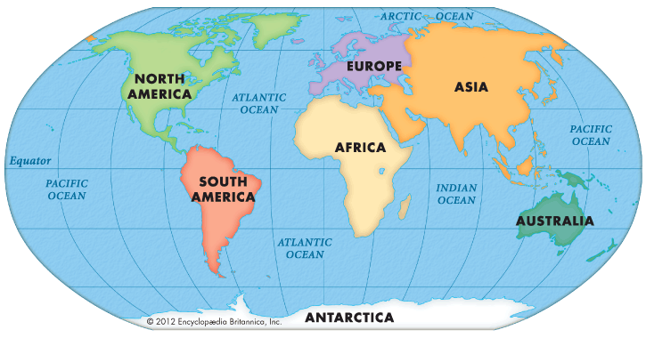
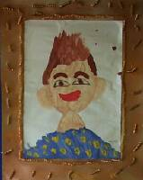  Draw a picture of yourself and write three things that make you wonderful. | Write a postcard to an Australian school child to tell them about Farnborough. | 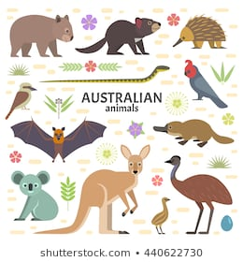  Research some of the animals you might find in Australia. Are there any animals that are different to the UK?
Don’t forget to try and read at home at least 3 times per week.

