Maths Answers
Lesson 1
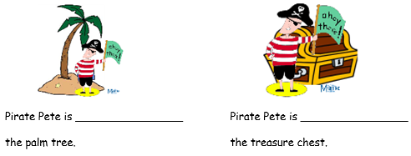
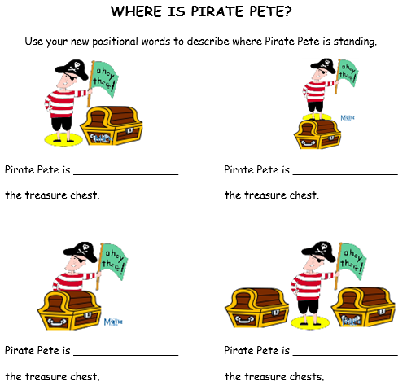
in front of
under
in between
behind
on top of
next to

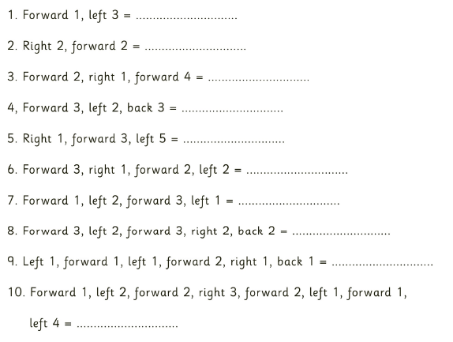
Lesson 2
coins
cutlass
flag
parrot
wheel
treasure chest
peg leg
map
compass
hook

Lesson 3
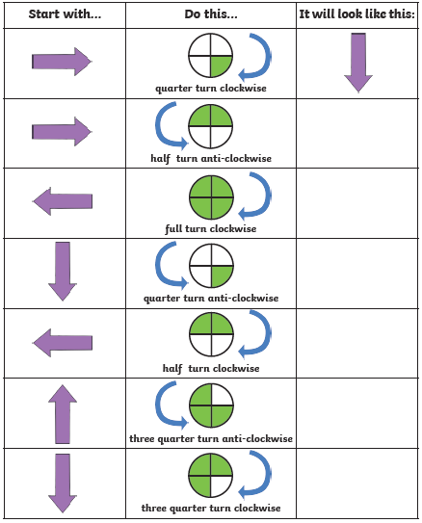
Challenge task

1. Forward 3, one quarter turn anti-clockwise, forward 4 = treasure chest

2. One quarter turn clockwise, forward 1, one quarter turn anti-clockwise, forward 6 = map

3. Forward 3, one quarter turn anti-clockwise, forward 2, one quarter turn anti-clockwise, forward 3 = peg leg

4. Forward 3, three quarter turn clockwise, forward 3, one quarter turn clockwise, forward 1 = parrot

5. One quarter turn anti-clockwise, forward 3, three quarter turn anti-clockwise, forward 6, one quarter turn anti-clockwise, forward 1 = coins

