Year 2 Maths Support Pack – Week 13
In this pack, you will find instructions on how to complete your Maths lessons for this week. We are learning about Measurement: Capacity and Volume this week and you will need to watch some short videos to help you. Follow the links on your home learning menu to watch the videos. You can then complete the worksheets by printing them, or viewing them on the screen and writing the answers on your own paper.

Lesson 1 – To be able to read the temperature on a thermometer
First complete the quiz to see what you already know. Then watch the video, pausing at the correct moments, to learn what temperature is and how to read this on a thermometer. The worksheet needed for the independent task is below. The answers are then given on the video, when you are ready. There are extra questions for you on the next page!
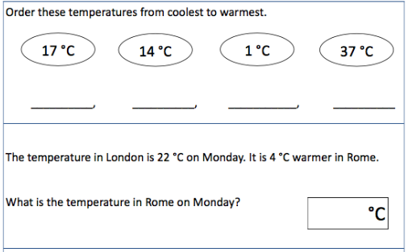

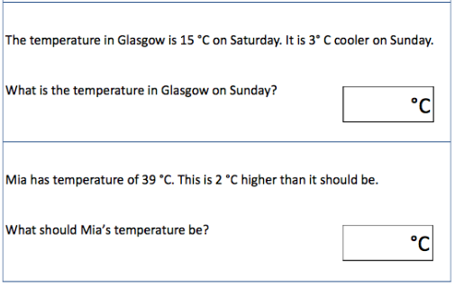

The temperature is different all around the world. Can you read the thermometer for each country to work out what temperature was last week?
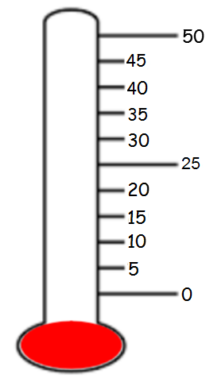
Italy
Australia
°C
°C
England
Spain

°C

°C

Which country was the hottest?
____________________________________________
Which country was 10 degrees hotter than Italy?
____________________________________________
Use < > or = to compare these temperatures:
Australia England

Italy Spain

Now can you create a block graph to show the temperature in each of the different countries?

Country | Temperature
Spain
England
Australia
Italy
Scotland | 0°C
Germany | 20°C
India | 45°C
South Africa | 30°C
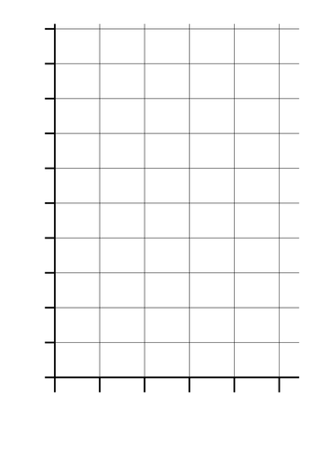
0°C
25°C
50°C

Lesson 2 – Grouping and the ÷ symbol
Today's lesson moves on from yesterday’s division as sharing to understanding division as grouping. When a quantity is put into equal groups, what you’re calculating is ‘how many groups’’. Watch the first video which shows how to put objects into equal groups and focuses on the language of 'into groups of'. Then watch the second video to look at the connection between 'into groups of' and the ÷ symbol.
There's also a reminder that division questions can be thought of as 'how many groups of … make …?' (for example how many groups of 10 make 80?).

Lesson 2 –

Lesson 2 – To be able to estimate and measure in litres
First complete the quiz to see what you already know about capacity and volume. Then watch the video, pausing at the correct moments, to learn what capacity and volume is and how to read this on a scale. The worksheet needed for the independent task is below. The answers are then given on the video, when you are ready. There are extra questions for you on the next page!
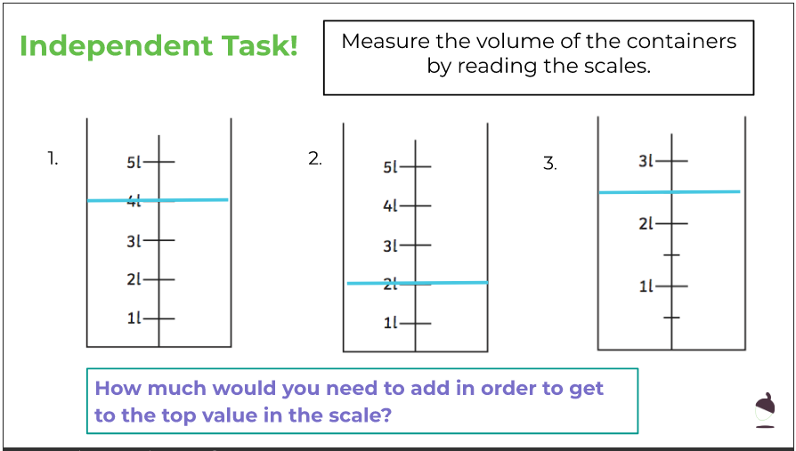

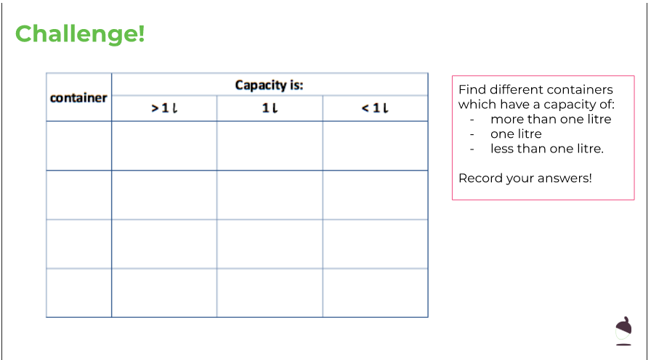

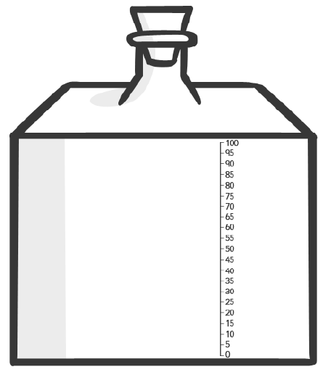
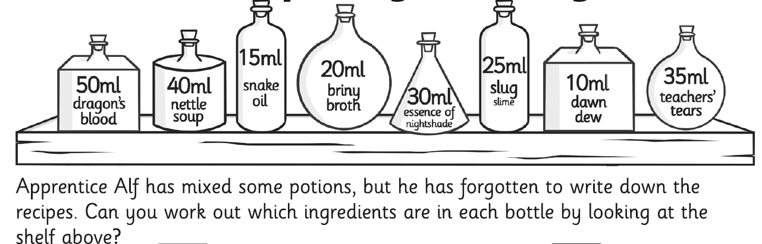
_____________________________
_____________________________
_____________________________
_____________________________
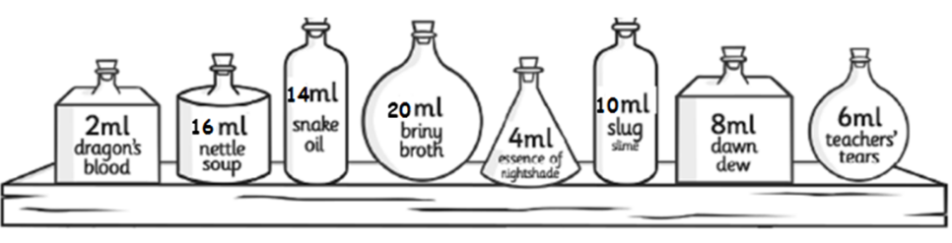
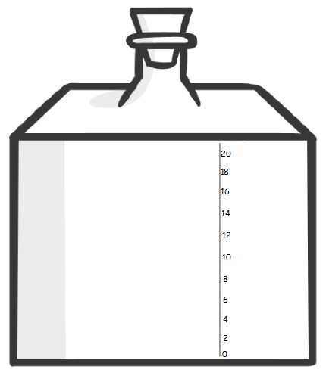
What about these ones?
_____________________________
_____________________________
_____________________________
_____________________________

Lesson 3 – To solve word problems that involve litres
First complete the quiz to see what you can remember about capacity, volume and litres. Then watch the video, pausing at the correct moments, to learn how to solve word problems that involve litres. The worksheet needed for the independent task is below. The answers are then given on the video, when you are ready.
