Year R Home Learning Menu – 22.6.20
Try to complete as many of the activities on this menu as you can during the week. If you would like more, log on to Teach Your Monster to Read, Oxford Owls or use some of the websites provided in the original pack. Please remember to take photos of any of the activities and upload onto EyLog so we can see what you have been doing!
Dinosaur Maths  Can you complete the dinosaur dot to dot?  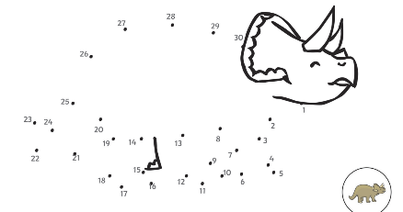  For more of a challenge can you create your own dot to dot picture? | Dinosaur Biscuits.  Can you follow the recipe with a grown up to make dinosaur footprint biscuits.  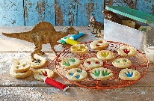  For more of a challenge, can you write what you had to do to make the biscuits? | Reading  Collect some objects from around your home. Ask a grown-up to write some simple sentences about the objects. Read them one at a time, then point to the matching object. For example, ‘This is a red ball’, ‘The box is big.’  For more of a challenge can you write sentences about a set of objects for your grown up to read and match.
Bug Hunt  Can you go on a bug hunt in your garden or on a walk.?  Use the sheet to tick off the bugs that you find.  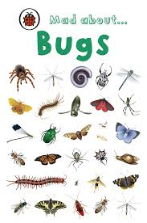  For more of a challenge, can you draw a picture of one of the bugs you found and write a sentence to describe it? | Maths-Teacher challenge  Watch Miss Carter’s phonics video on the school website. Can you say the sounds and read the magic words.  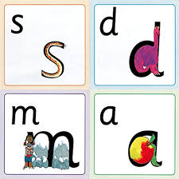  Listen out for the extra challenge on the video! | Dinosaur Movement  Cut out the dinosaur dice and stick it together. Roll the dice and do the dinosaur movement.  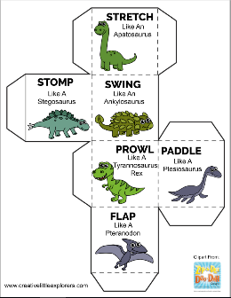  For more a challenge can you draw a picture of you doing your favourite move.

