Year 2 English Support Pack – Week 9
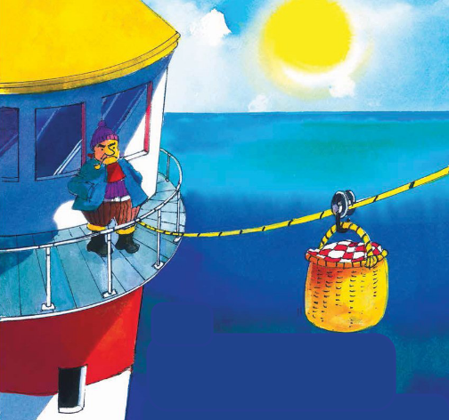
Lesson 1 – Predicting

What do you think is happening in the picture? What do you think our new story might be about?
____________________________________________________________________________________________________________________________________________________________________________________________________________________________________________________________________________________________________________________________________________________________
Lesson 2 – Comprehension
Listen to our new story being read by Miss Stratton on the VLE and the website. There is also a copy of the text on the next page of this pack in case you need it.
Then have a go at answering these questions about the story.

1. What is Mr Grinling’s main task that he has to do as a lighthouse keeper?
___________________________________________________
2. How do you think Mr Grinling feels about his job? Why?
______________________________________________________________________________________________________
3. How did Mr Grinling know that the light was working, when he was at home?
______________________________________________________________________________________________________
4. Find and copy the word that describes Mr Grinling’s lunch.
________________________________
5. Why didn’t Mr Grinling get his lunch on Monday?
___________________________________________________
6. What was the first plan that Mr and Mrs Grinling came up with to stop the seagulls? Did it work?
______________________________________________________________________________________________________
7. What day did they decide to put their cat into the basket?
___________________________________________________
The Lighthouse Keeper’s Lunch

Once there was a lighthouse keeper called Mr Grinling. At night time he lived in a small white cottage perched high on the cliffs. In the day time he rowed out to his lighthouse on the rocks to clean and polish the light.

Mr Grinling was the most industrious lighthouse keeper. Come rain or shine, he tended his light.
Sometimes at night, as Mr Grinling lay sleeping in his warm bed, the ships would toot to tell him that his light was shining brightly and clearly out to sea.

Each morning while Mr Grinling polished the light Mrs Grinling worked in the kitchen of the little white cottage on the cliffs concocting a delicious lunch for him. Once she had prepared the lunch she packed it into a special basket and clipped it on to the wire that ran from the little white cottage to the lighthouse on the rocks.

But one Monday something terrible happened. Mrs Grinling had prepared a particularly appetising lunch. She had made…a mixed seafood salad, a lighthouse sandwich, cold chicken garni, sausages and crisps, peach surprise, iced sea biscuits, drinks and assorted fruit. She put the lunch in the basket as usual and sent it down the wire.

But the lunch did not arrive. It was spotted by three scavenging seagulls who set upon it and devoured it with great gusto. “Clear off your varmints,” shouted Mr Grinling, but the seagulls took not the slightest notice.
The seagulls - “This is an excellent peach surprise, boys,” “She’s a great cook, Fred,” “Scrumptious lunch, Tom.”

That evening Mr and Mrs Grinling decided on a plan to baffle the seagulls. “Tomorrow I shall tie the napkin to the basket,” said Mrs Grinling. “Of course, my dear,” agreed Mr Grinling, “a sound plan.”
The seagulls – “They’ll have to try harder than this to stop us, Bert.”

On Tuesday evening Mr and Mrs Grinling racked their brains for another plan. “They are a brazen lot, those seagulls,” said Mrs Grinling. “Brazen indeed,” said Mr Grinling, “what shall we do?”
“Our cat does not appear to like seagulls,” said Mrs Grinling. “No my dear,” said Mr Grinling, “Hamish is an accomplished seagull chaser.”
“Of course,” exclaimed Mrs Grinling, “tomorrow Hamish can guard the lunch.” “A most ingenious plan,” agreed Mr Grinling.
Hamish did not think this plan was ingenious at all. He spat and hissed as Mrs Grinling secured him in the basket. “There, there, Hamish,” said Mrs Grinling consolingly, “I’ll have a tasty piece of herring waiting for you when you arrive home.”

Sadly, flying did not agree with Hamish. His fur stood on end when the basket swayed, his whiskers drooped when he peered down at the wet, blue sea and he felt much too sick even to notice the seagulls, let alone scare them away from the lunch.
The seagulls – “Pretty kitty, like a piece of lobster mornay?” “This food gets better every day, Fred,” “Aren’t you going to chase us, kitty?”
“Lackaday, lackaday,” said Mr Grinling sadly. “Miaow, miaow,” agreed Hamish pitifully.

On Wednesday evening Mr and Mrs Grinling racked their brains again for a new plan. “What shall we do?” said Mr Grinling. Mrs Grinling looked thoughtful. “I have it!” she exclaimed. “Just the mixture for hungry seagulls.” “Indeed, my dear,” said Mr Grinling. “What have you in mind?” “Wait and see,” said Mrs Grinling, “just wait and see.”
“Mustard sandwiches,” chuckled Mr Grinling. “A truly superb plan my dear, truly superb.”
On Thursday morning Mrs Grinling carefully packed the mustard sandwiches and sent them off down the wire to the expectant seagulls.
The seagulls – “YUK!” “UGH!” “AAAAK!”

On Friday Mrs Grinling repeated the mustard mixture.
The seagulls – “It’s the same as yesterday’s lunch Fred.” “All right boys, let’s go and have lunch elsewhere.”

So on Saturday, up in the little white cottage on the cliffs, a jubilant Mrs Grinling put away the mustard pot before she prepared a scrumptious lunch for Mr Grinling. While he waiting for his lunch down in the lighthouse on the rocks, Mr Grinling sang snatches of old sea shanties as he surveyed the coastline through his telescope…and this is what he saw…
The seagulls – “No mustard in this lot, Tom.” “We’ll fly back here for lunch again tomorrow, boys.” “This is a delicious chocolate éclair, Fred.”

“Ah well, such is life,” mused Mr Grinling as he sat down to enjoy a leisurely lunch in the warm sunshine.
Lesson 3 – Vocabulary
There are lots of interesting words in the story. Lots of them you may not have heard before. Read these words carefully and see if you can find out what they mean. Ask your grown up or use a dictionary or search engine to look them up.
Definition – What does it mean?
industrious
concocting
appetising
scavenging
devoured
brazen
ingenious
Extension task – Can you complete the thought bubbles to show what the different characters might be thinking or feeling at this point in the story?
