Whole School Home Learning Menu
Make a robot out of anything around your house.  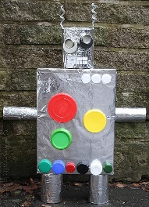 | Learn and recite a poem off by heart – can you record it and send it to your teacher on the VLE?   | Draw a picture of a place you would like to visit. Can you write a description of it?   | Take a walk and make a picture out of items you found.  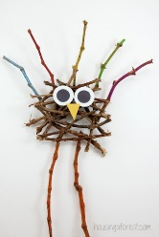
Write a lovely letter to a friend or family member. Walk to the post box and post it to them.  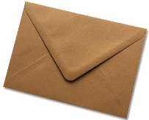 | Create your own story in a box/jar.  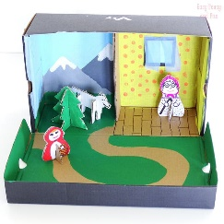 | Tie dye an old white t-shirt or draw a bright picture on one.  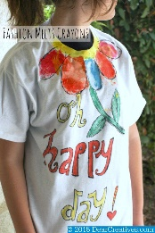 | 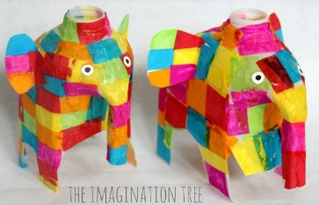  Make a ‘milk bottle elephant’ out of an old milk bottle.
Make your own ‘fake-away’ boxes for a yummy dinner.  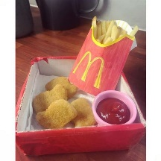 | Design and create your own space rocket. Write a story about and adventure to space.  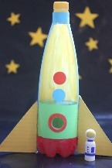 | Create your own word search or crossword.  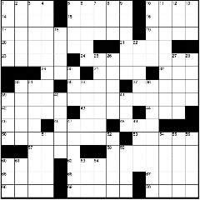 | Watch a film you’ve never seen and write a film review.  
Build a den!  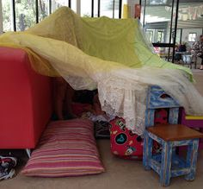 | Learn how to play a card game and teach it to a family member. If you don’t have cards, you could make your own.  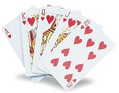 | 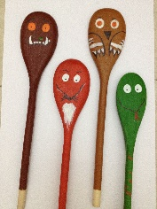  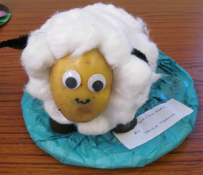  Make a book character out of household items | Find a cosy place at home and record yourself reading a story to yourself or a family member.  

